* 1. General Information

|  |  |  |  |  |  |
| --- | --- | --- | --- | --- | --- |
| **Design Code** | **Unit System** | **Span** | **Thickness** |  |  |
| IS456:2000 | N, mm | 4.000m | 201mm | 25.00MPa | 415MPa |

* 1. Design Load & Support Condition

|  |  |  |  |
| --- | --- | --- | --- |
| **Dead Load** | **Live Load** | **Slab Type** | **Support Type** |
| 2.000kN/m² | 2.000kN/m² | 1-Way Slab | Support Case-1 |

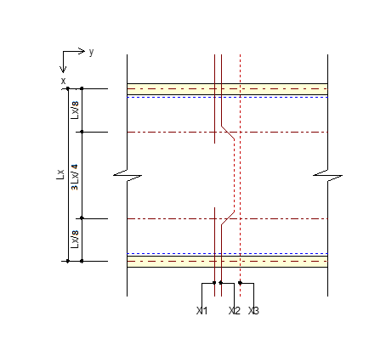

* 1. Check Thickness & Deflection

|  |  |  |  |
| --- | --- | --- | --- |
| **Check Items** | **Input** | **Criteria** | **Ratio** |
| Required minimum thickness (mm) | 201 | 200 | OK(0.995) |
| Totla deflection (mm) | 0.000 (L/0.000) | 0.000 (L/250) | OK(0.000) |

* 1. Check Moment & Shear Capacity

|  |  |  |  |
| --- | --- | --- | --- |
| **Check Items** | **TOP** | **MIDDLE** | **BOTTOM** |
| Bar-1 | P5@450 | P5@450 | P5@450 |
| Bar-2 | P5@450 | P5@450 | P5@450 |
| Bar-3 | P5@450 | P5@450 | P5@450 |
|  | 3.733 | 11.20 | 3.733 |
|  | 11.20 | 0.000 | 11.20 |
|  | 52.59 | 52.59 | 52.59 |
|  | 108 | 108 | 108 |
|  | OK(0.0710) | OK(0.213) | OK(0.0710) |
|  | OK(0.104) | OK(0.000) | OK(0.104) |
|  | 315 | 315 | 315 |
|  | OK(0.714) | OK(0.714) | OK(0.714) |